Harmony Lodge No. 9, F&AM

Back by Popular Demand:
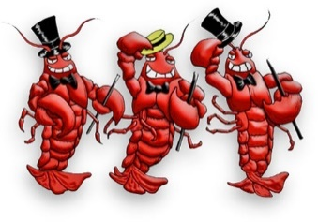
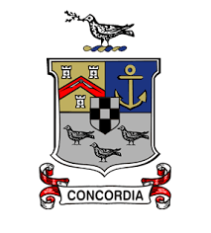
Annual Adult Getaway Weekend
The Cape Codder Resort and Spa
1225 Ivannough Road
Hyannis, MA 02601
Please join us in Hyannis, MA for fun, fellowship, and frivolity at our newly invigorated getaway weekend!

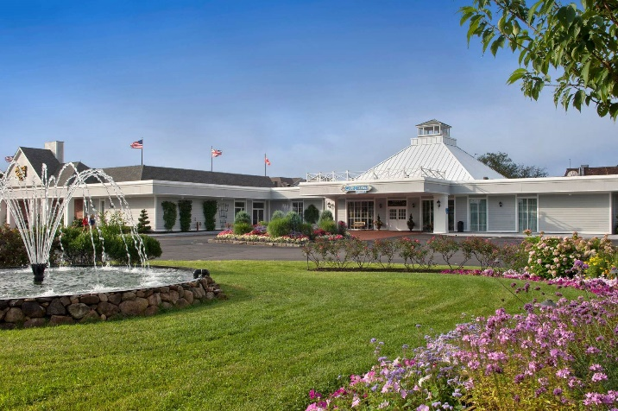

Friday February 4 to Sunday February 6, 2022.

Brothers: the leadership of Harmony Lodge is thrilled to invite you to celebrate fraternal and family fellowship at the annual Cape Cod getaway weekend to be held the weekend of February 4 to 6, 2022. Our presumptive 2021-2022 Worshipful Master, Josh Edwards, has decreed that a social weekend with friends and family is long overdue, and that fun and games shall abound! This social weekend will be “just what the doctor ordered” to help make the long New England winter a bit more bearable.

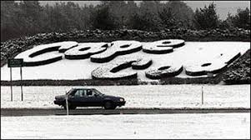
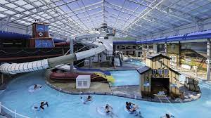
On Friday afternoon, Brothers and their families and friends lucky enough to attend this event will register at the Cape Codder Resort and Spa any time after 3pm, after which, they will also have access to the private use of a hospitality room and enjoy a libation or two and some light hor d’oeuvres in a fun, friendly social environment. The Cape Coder is a unique hotel just minutes from downtown Hyannis and about a 2-hour drive from Providence. Access to their world-famous water park is available at a discounted rate.

During the day Saturday, attendees will be free to explore the area, and despite our event being off-season, there will be many activities from which to choose. Stay tuned for details of sightseeing options as we get closer to the event!

On Saturday evening, attendees will be invited to a social hour, followed by a sit-down dinner in a private setting. The traditional Yankee swap will be held after dinner. Please plan to bring a gift of around $20 to participate. This event is always great for more than a few laughs! The hospitality room will then be made available through the rest of the evening for more socializing and fellowship.

Harmony Lodge is looking forward to welcoming you to Hyannis. We cannot wait to be your host for what promises to be a very special event!
Registration Form

Name: ___________________________________________________ Guest:_____:____________________________

Address: __________________________________________________________________ ________________________

City, State, Zip: ____________________________________________ Cell Phone: _____________________________

Email: ____________________________________________________ Home Phone: ___________________________

Bed Preference: 1 King Bed 2 Queen Beds

A $150 deposit by November 1, 2021 secures your reservation. Remaining payment balance is due by January 15, 2022.

- “Early Bird” Couple Registration (before Oct. 15) $315

- “Early Bird” Single Registration (before Oct. 15) $295

- Couple Registration: $375

- Single Registration: : $325
Total: $ _______

Please check your registration preference above and include with this form a check in the appropriate amount made out to Harmony Lodge No. 9, F&AM. Please note that the registration deadline is Monday November 1, 2021.

Mail to:
Michael Cunningham
8 Beatrice Terrace
Warwick, RI 02889

Email: macunningham9@yahoo.com Telephone: (919) 740-6776

Weekend Agenda

Friday Feb 4 3pm Onwards Arrival and Registration
Friday Feb 4 5pm to ??? Hospitality Room Open
Saturday Feb 5 Morning Breakfast on your own
Morning/Afternoon Explore Cape Cod on your own
5pm Social Hour in Hospitality Room
6pm Dinner
8pm to ??? Yankee Swap, Hospitality Room Open
Sunday Feb 6 Morning Breakfast on your own, Safe travels, See you next year!

Please include any dietary restrictions and/or hotel room requirements with your registration.

Dress for the weekend is casual Please note that this is an adults only event

